|  |  |  |
| --- | --- | --- |
| **LAB 321Assignment** | **Type:** | **LongAssignment** |
| **Code:** | **3** |
| **LOC:** | **500** |
| **Slot(s):** | **3-4** |

**Title:** Product discount display

**Background**

The shop owner wants to discount some of their products. The originated price should be view beside the discount price in order to help the buyer imagines how much he could save with the discount price.

**Program Specifications**

This feature helps the end user handle with discount feature via friendly user interface without any requirement of technical or IT skill.

**Features:**

This website contains 2 main functions

* Function 1 : Add product with fields: name, image, 2 fields of price: discount price and normal price (PIC 01)
* Function 2 : Price list ( PIC 02)
  + List the products with picture as picture 2.
  + With the product has discount price, view the normal price with a strikethrough, and display the discount price beside. Then calculate the percentage of the sale off.
  + With the product only have one price, i.e no discount applied, show as nornal

You do not need to write interface for admin control panel, you can add data manually (use SQL SERVER Management studio).

Note: All data must be load from database, not hard code in page.

***Expectation of User interface:***

Pic 01 : Add new Product

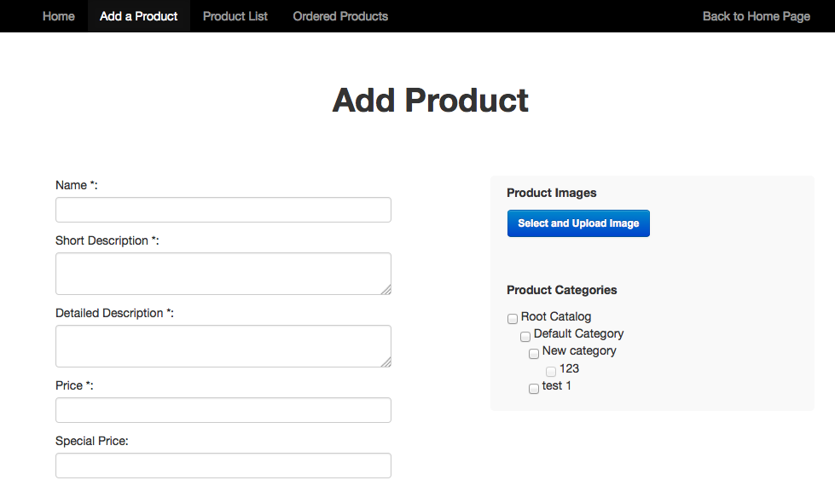

Pic 02 : Product display with discount information

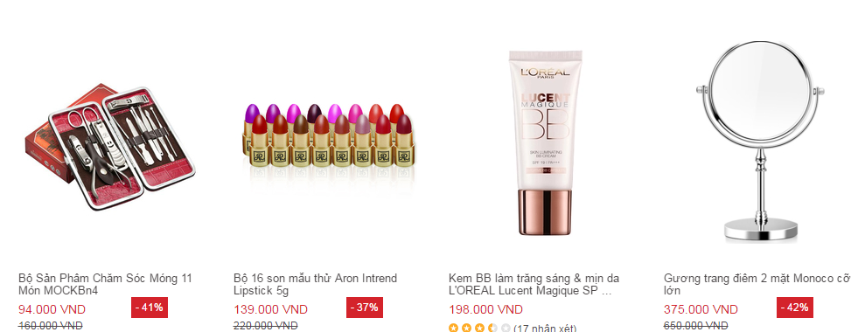

**Guidelines**

* Step 1 : Create web layout
* Step 2 : Create prototype
* Step 3 : Design database base on created prototype
* Step 4 : Code & Test